**Swagger-UI URL:** <http://localhost:8080/swagger-ui.html>

**Swagger-UI Home Page:**

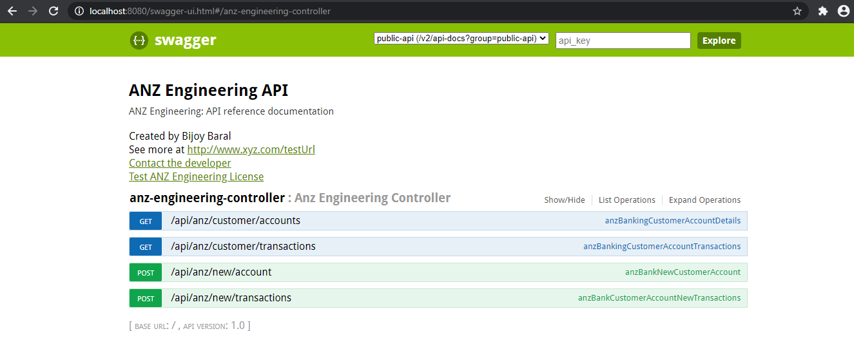

**REST API to create new bank account(s):**

**Request type**: POST

**Request URL**: <http://localhost:8080/api/anz/new/account>

**Input type**: JSON

**Output type**: TEXT

**Input**:

{

"accountNumber":7000,

"accountName":"Test Account Name",

"accountType":"Savings Account",

"balanceDate":"2011-08-22",

"currency":"AUD",

"openingAvailableBalance":20040000000,

"userCode":"BK"

}

**Output**: ANZ account: Customer account have been created successfully. And the account number is: 9000

**Sequence of Screenshots**:

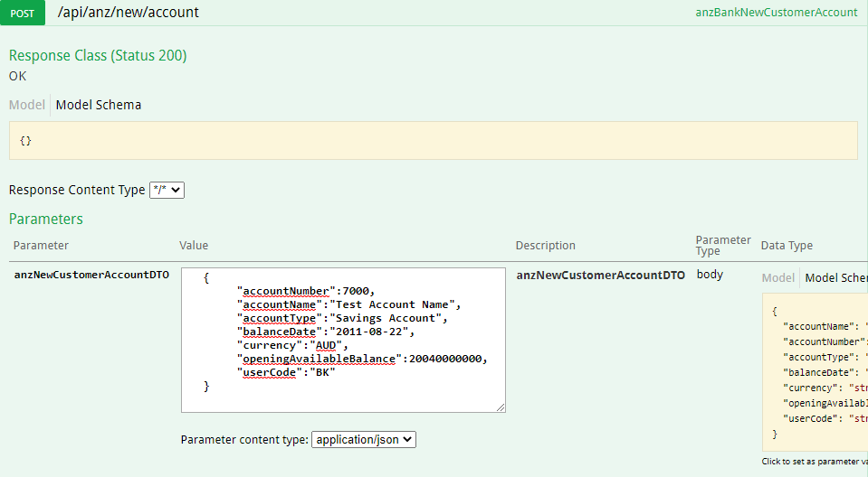

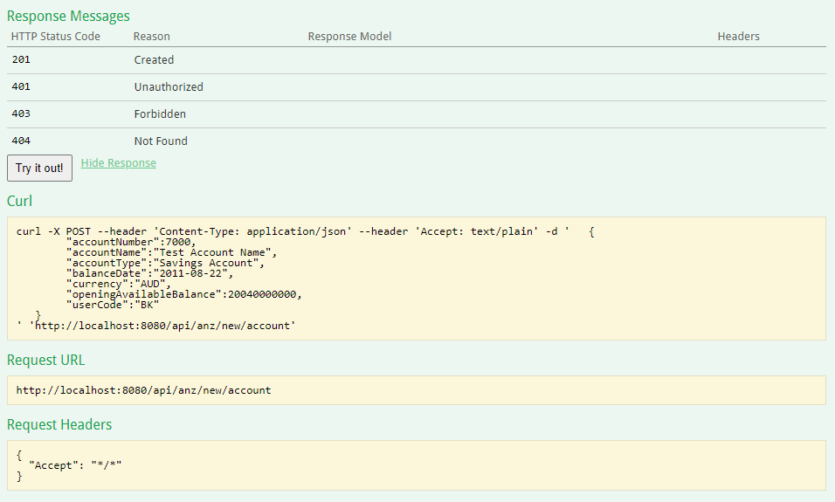

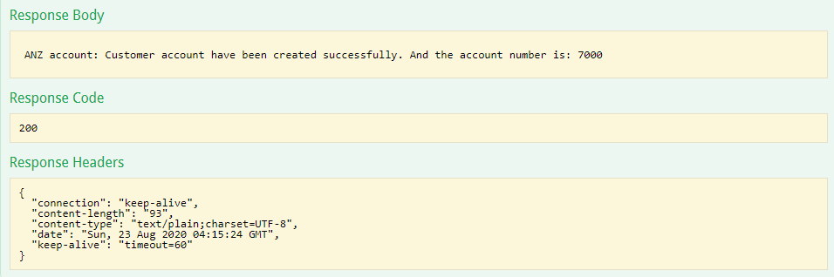

**REST API to support listing of account(s) of a user:**

**Request type**: GET

**Output type**: JSON

**Request URL**: http://localhost:8080/ api/anz/customer/accounts?userCode=BK

**Output**:

[

{

"id": 3,

"accountNumber": 7000,

"accountName": "Test Account Name",

"accountType": "Savings Account",

"balanceDate": "2011-08-22T00:00:00.000+00:00",

"currency": "AUD",

"openingAvailableBalance": 20040000000,

"userCode": "BK"

}

]

**Sequence of Screenshots**:

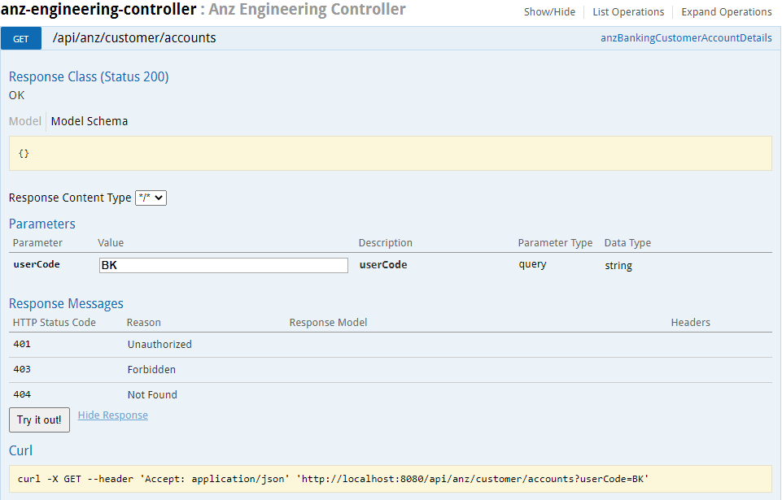

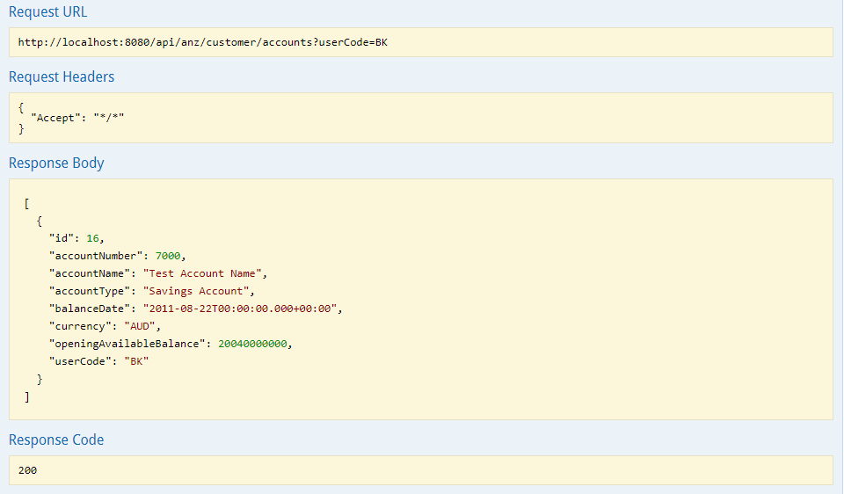

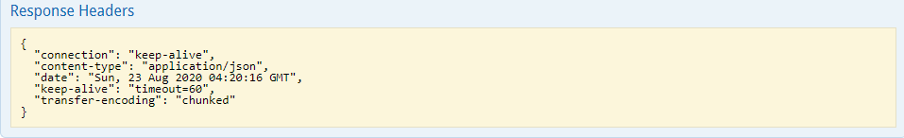

**REST API to create bank account(s) transactions:**

**Request type**: POST

**Input type**: JSON

**Output type**: TEXT

**Request URL**: http://localhost:8080/api/anz/new/transactions

**Input**:

{

"accountNumber": 8000,

"accountName":"Test Account Name",

"valueDate":"2011-08-22",

"currency":"AUD",

"debitAmount":12,

"creditAmount":20040000000,

"debitOrCredit":"Credit",

"transactionNarative":"Test Transaction Narrative"

}

**Output**: ANZ transactions: Customer new transaction details have been created.

**Sequence of Screenshots**:

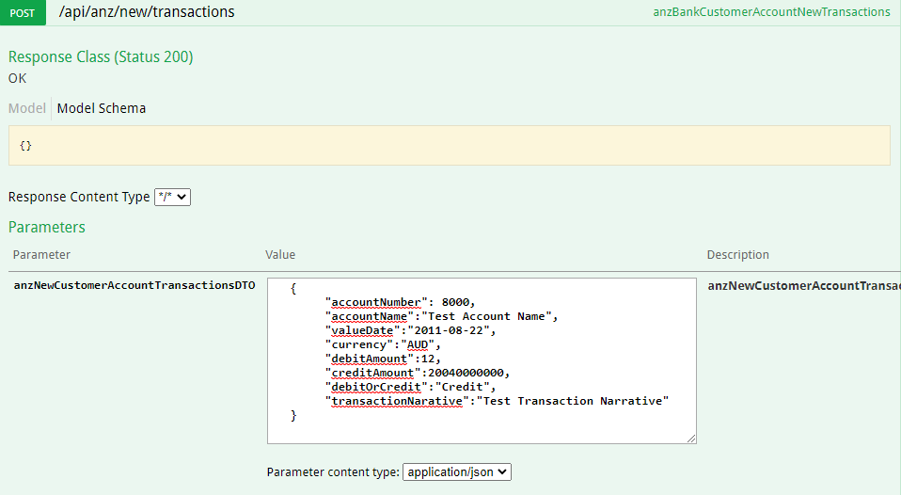

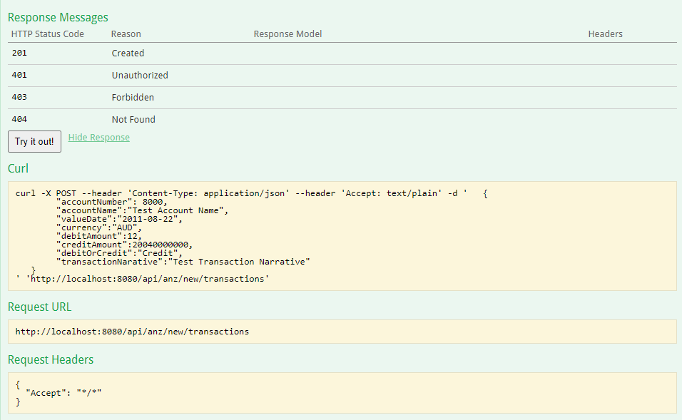

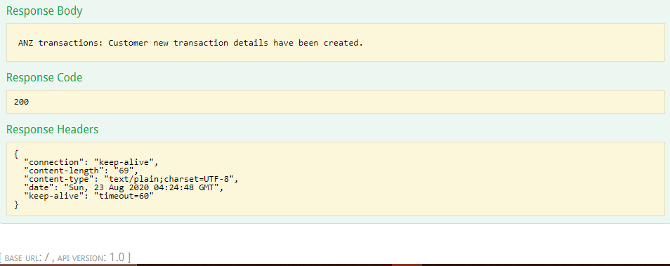

**REST API to create bank account(s) transactions:**

**Request type**: GET

**Output type**: JSON

**Request URL**: http://localhost:8080/api/anz/customer/transactions?accountNumber=8000

**Output**:

{

"accountNumber": 8000,

"accountName":"Test Account Name",

"valueDate":"2011-08-22",

"currency":"AUD",

"debitAmount":12,

"creditAmount":20040000000,

"debitOrCredit":"Credit",

"transactionNarative":"Test Transaction Narrative"

}

**Sequence of Screenshots**:

